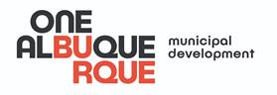 | FOR IMMEDIATE RELEASE  Contact: Johnny Chandler | 505-331-7729  April 27, 2020

Rio Grande Boulevard Update Includes Roadway Rehab, ADA Accessibility

Project to make Rio Grande safer for cars, cyclists, pedestrians will be completed while traffic is light due to people staying home

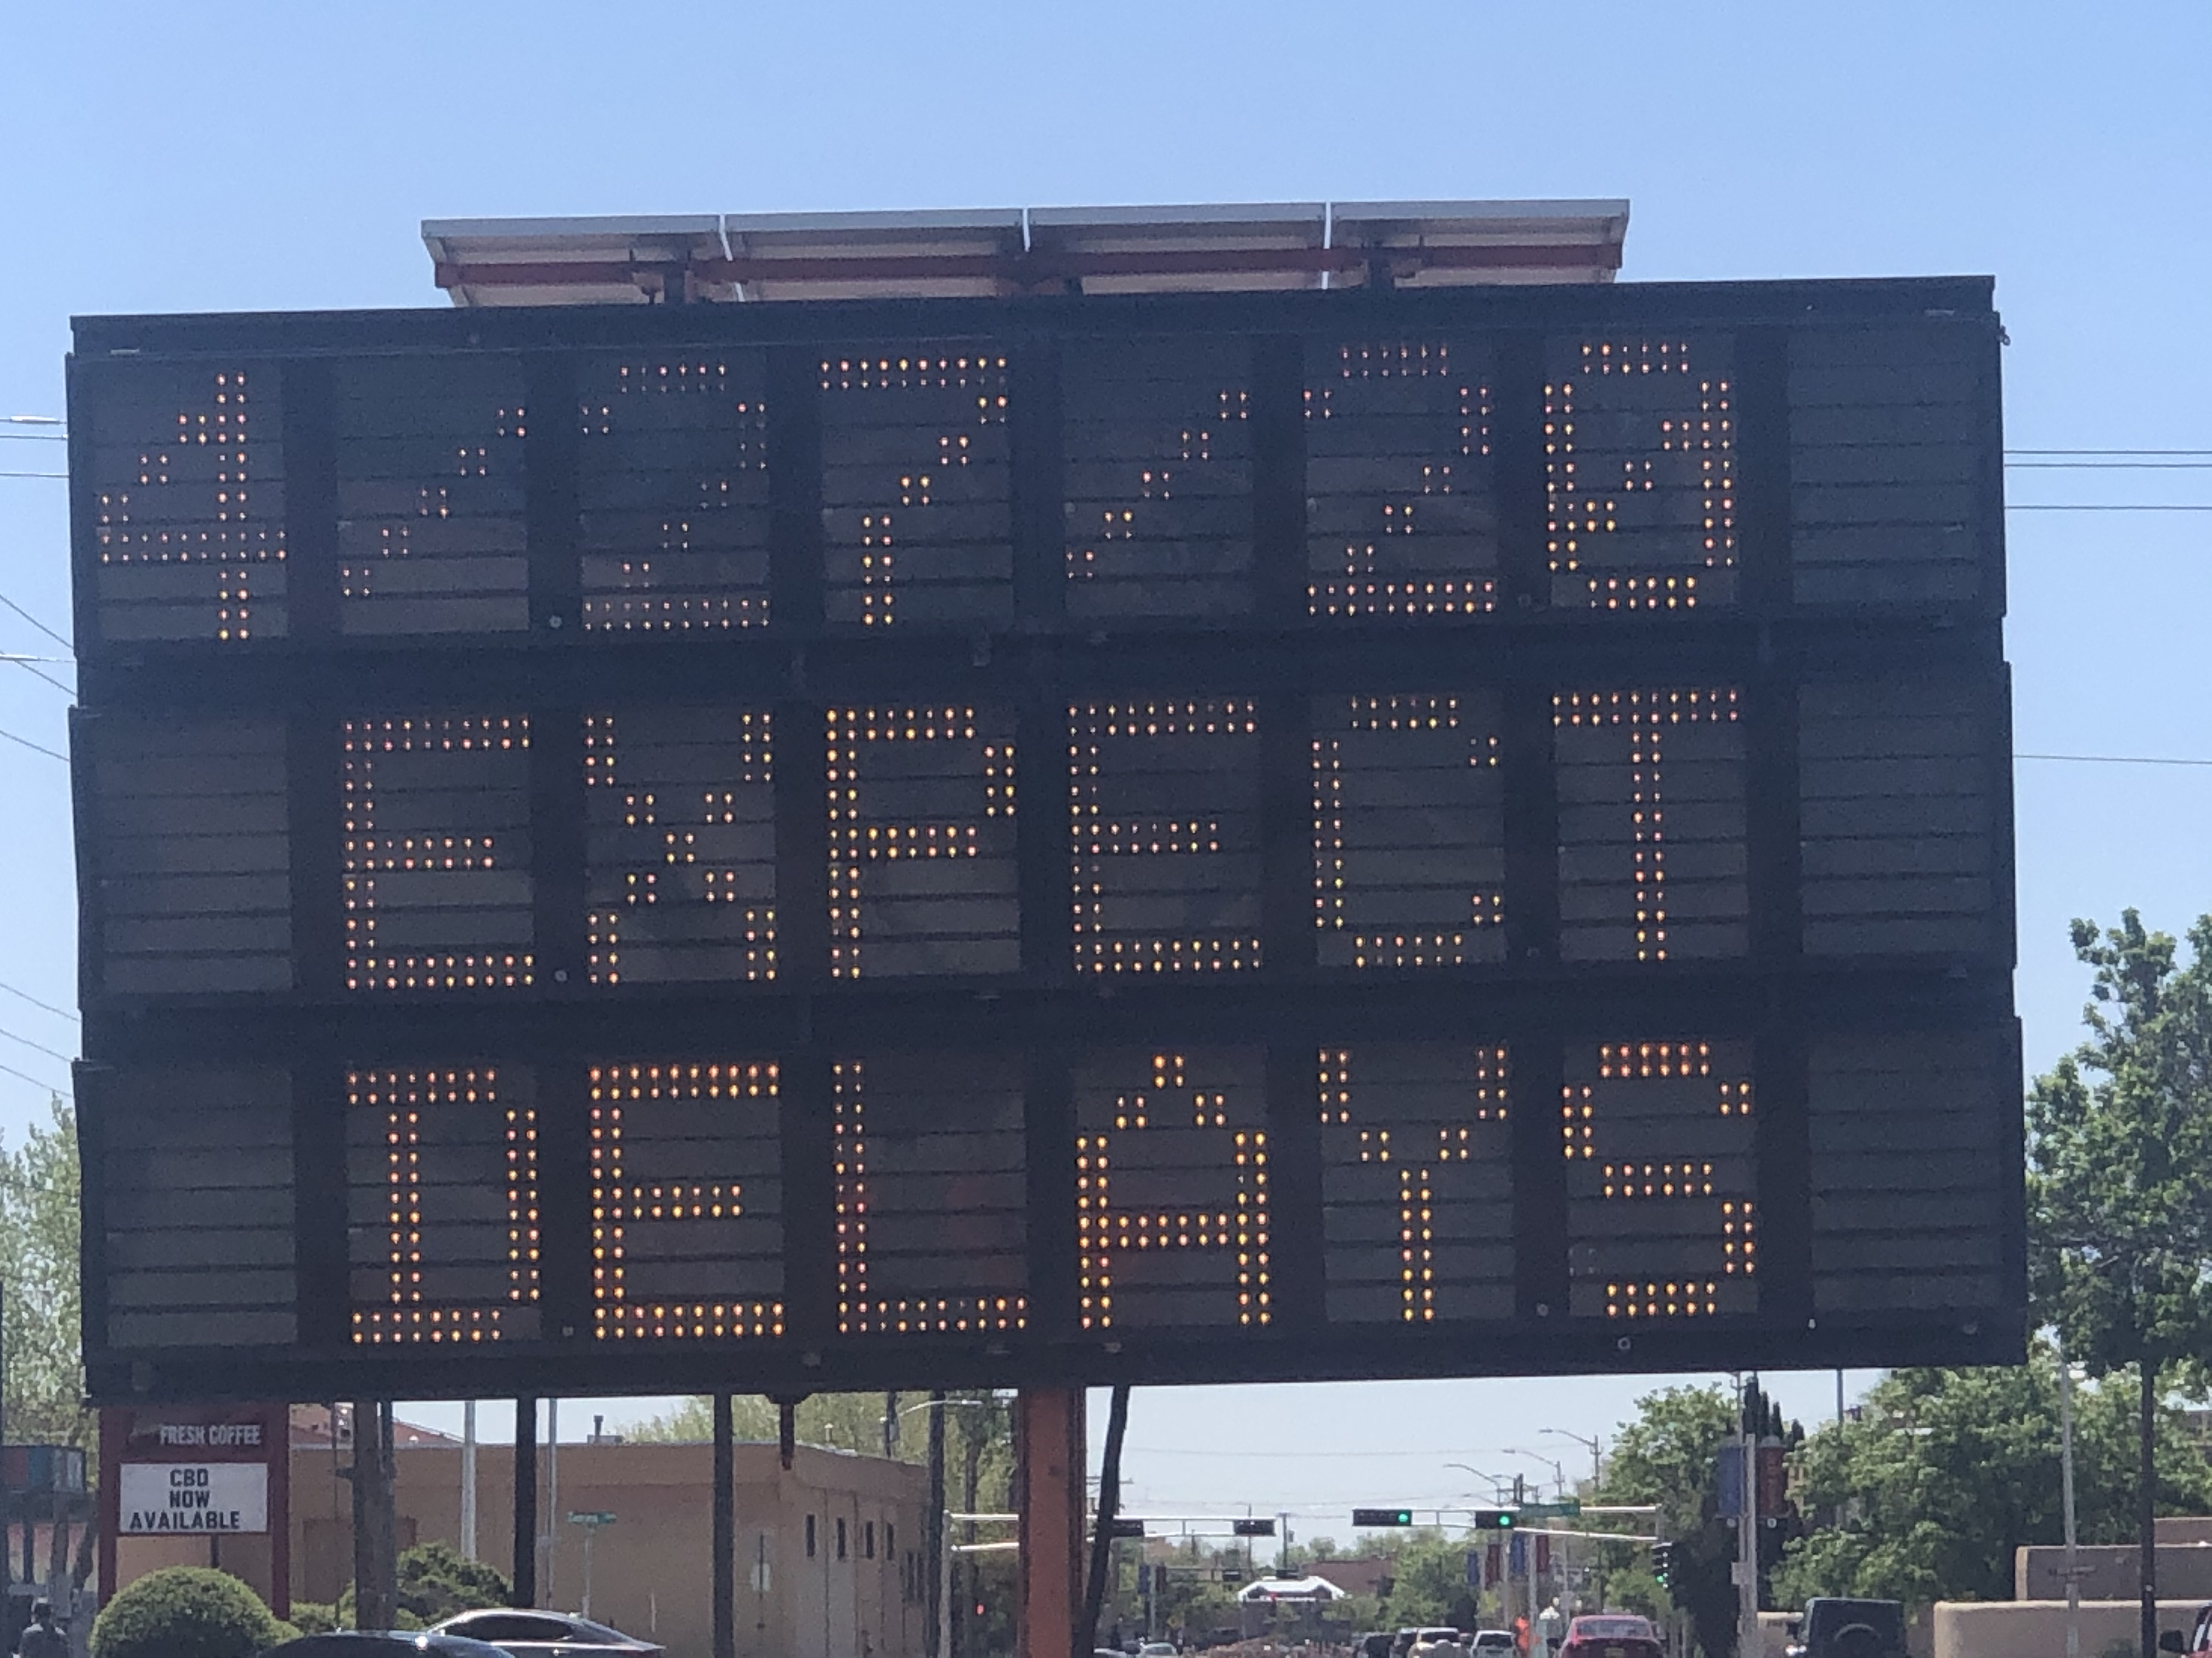
ALBUQUERQUE, N.M. – Mayor Tim Keller announced another road work project while traffic is light due to people staying home. The $1,000,000 in street maintenance funds will upgrade one of Albuquerque’s busiest streets for visitors and locals alike: Rio Grande Boulevard NW between Central and I-40. Road rehabilitation starts on Monday¸ April 27, 2020 and Complete Streets striping will be completed by the end of May.
“Rio Grande Boulevard is one of Albuquerque’s busiest gateways,” said Mayor Tim Keller. “For hundreds of thousands of annual residents and visitors who use it to access Old Town, the Sawmill Market, and the BioPark, we’re making this stretch of roadway safer to walk, bike or drive.”

The project will take place while traffic is light due to people staying home. Construction projects keep money flowing in the local economy and ease the recovery when the City re-opens.

DMD started work on ADA sidewalk improvements last month. This work included new drive pads, ADA accessible ramps, and new sidewalk pads where needed. With that work now completed, the DMD Street Maintenance Division is giving this critical roadway a makeover.

New roadway striping will start Monday, April 27, 2020 in accordance with the Complete Streets Ordinance. In order to accommodate all modes of transportation and calm traffic in the corridor, DMD will narrow road lanes to 10 ½ feet in width and extend the bicycle lane on both ends of the street that will vary in width from 4 to 5 feet.

DMD Director Pat Montoya said, “We’re also looking at long-term improvements for this heavily visited corridor that will make Rio Grande Blvd. between I-40 and Central even more bicycle and pedestrian friendly and reduce the risks of collisions.”

###

